Enchanted Wings:
Marvels of Butterfly Species

Name: G. Himanjali
College: Vishnu Institute of Technology, Bhimavaram
Course: B.Tech in Information Technology

Email:22pa1a1244@vishnu.edu.in

Registration Number:22PA1A1244

Team ID:LTVIP2025TMID36086
📚 Table of Contents
- Project Overview
→ Summary of the Butterfly Classification Project
- Problem Statement
→ Real-world significance and motivation
- Objectives
→ Key goals and what the project aims to achieve
- System Architecture
→ End-to-end flow: Data → Model → Prediction → UI
- Prerequisites
→ Tools, libraries, environment setup
- Dataset Collection
→ Source of data, number of images, species coverage
- Data Preparation
→ Preprocessing steps
- Model Building and Training
→ Use of Transfer Learning (VGG16), training procedure
- Model Evaluation & Testing
→ Accuracy, validation set, test results, metrics
- Application Interface Development
→ Flask backend, HTML/CSS frontend, functionality overview
- Use Case Scenarios
- Conclusion
→ Summary, key outcomes, future improvements
- References
→ GitHub repo, dataset source, video demo link

1.Project Overview
Title: Enchanted Wings: Marvels of Butterfly Species
The Enchanted Wings project is an intelligent image classification system designed to accurately identify butterfly species using deep learning and transfer learning techniques. This project aims to address the challenges of butterfly species identification by creating a web-based application powered by a pre-trained convolutional neural network (CNN), specifically the VGG16 model.
Butterflies play a vital role in the ecosystem as pollinators and biodiversity indicators. However, manual identification of butterfly species in diverse environments can be time-consuming and error-prone. To solve this, our project automates the process through an AI-driven approach that classifies uploaded butterfly images into their respective species.
The model is trained on a dataset containing 6,499 images across 75 butterfly classes, ensuring a broad understanding of various species. By leveraging transfer learning, the system accelerates training time and enhances accuracy by reusing features learned from a large dataset (ImageNet).
This project combines machine learning with web development to offer a user-friendly interface, allowing users to:
- Upload an image of a butterfly.
- Receive instant predictions about its species.
- Learn about the application via embedded About and Contact sections.
It is especially beneficial for:
- Researchers and conservationists working on biodiversity monitoring.
- Students and educators in ecological and biological sciences.
- Citizen scientists and nature enthusiasts.
In addition to the machine learning model, the project includes a fully functional web interface built using HTML, CSS, and Flask, making it accessible and intuitive. All development was done using Google Colab for model training and VS Code for front-end and back-end integration.

2.Problem Statement
Butterflies, with their striking colors and intricate patterns, are more than just beautiful insects. They play a vital ecological role as pollinators, biodiversity indicators, and components of various food webs. However, the world is witnessing a drastic decline in butterfly populations due to factors such as climate change, habitat destruction, pollution, and invasive species. The urgency to monitor, document, and conserve these species has never been greater.
Traditional methods of butterfly identification rely heavily on expert entomologists, detailed field guides, and time-consuming manual classification. For researchers in remote or under-resourced areas, or even for enthusiastic citizen scientists, this becomes a barrier to contributing to biodiversity data. Moreover, in fast-paced ecological studies or field surveys, real-time identification is essential to making quick, data-driven conservation decisions.
In such scenarios, AI-driven image classification models have the potential to revolutionize how species are identified, catalogued, and monitored. With a simple photo taken from a smartphone, anyone—researcher, student, or enthusiast—can get instant predictions of butterfly species with remarkable accuracy. This kind of democratization of ecological tools empowers wider participation in conservation and makes ecological monitoring more efficient and scalable.

Motivation Behind the Project
The primary motivation for this project emerged from a blend of technological innovation and environmental awareness. The goal was to harness the power of transfer learning—a machine learning technique where a pre-trained model is adapted for a new but similar task—to accurately identify butterfly species from images.
Several motivations guided the project:
- Accessibility to Non-Experts: Not everyone has the knowledge or access to experts to classify species. Building a simple web app allows any user to upload an image and receive species identification results without needing domain-specific knowledge.
- Support for Biodiversity Research: Environmentalists, ecologists, and students can use this system to track species distribution, observe migration patterns, and detect invasive or rare species, which helps in data collection and decision-making.
- Efficient Use of Technology: Instead of training a deep learning model from scratch—which is time-consuming and resource-intensive—this project uses VGG16, a powerful CNN model pre-trained on ImageNet. This helps in achieving high accuracy with less computational cost and time, making it ideal for educational institutions and NGOs with limited resources.
- Educational Value: The project also aims to serve as a learning tool. Students studying biology, computer vision, or AI can explore how deep learning models can be trained, fine-tuned, and deployed in a real-world application. It bridges the gap between theory and practical implementation.
- Citizen Science and Engagement: By building a platform that allows easy butterfly identification, the project encourages citizen participation in scientific research. People can take part in ecological monitoring efforts and contribute valuable data that may influence policy or conservation actions.
- Awareness and Conservation: The visual appeal of butterflies often draws public interest. An interactive platform that classifies species can be used in campaigns, awareness programs, and nature walks to educate the public and foster conservation values.

Scope of the Problem
- Manual butterfly classification is not scalable for large-scale biodiversity studies.
- There is a need for accessible, fast, and accurate tools to assist researchers and learners alike.
- Existing solutions are often not tailored for Indian/local butterfly species or are restricted to mobile apps with limited datasets.
- Building an open, web-based classifier with educational value solves both the technical and accessibility challenges.

This project is a response to the global call for AI for Good—leveraging modern artificial intelligence technologies to solve environmental challenges and empower communities, researchers, and learners to engage with nature more deeply and effectively.

3.Objectives

Primary Goal
The primary objective of this project, “Enchanted Wings: Marvels of Butterfly Species”, is to build a robust, AI-powered image classification system that can accurately identify butterfly species from uploaded images. The solution must be user-friendly, efficient, and educational, catering to both professionals in biodiversity research and curious learners or enthusiasts.
This goal is achieved through the integration of deep learning techniques, specifically transfer learning using the VGG16 convolutional neural network, deployed via a simple yet interactive web application.

Key Objectives

✅ 1. Develop a Reliable Image Classification Model
The cornerstone of the project is a machine learning model capable of classifying butterfly species with high accuracy. For this:
- A dataset containing 6,499 butterfly images across 75 species is curated.
- The dataset is preprocessed and augmented to improve model generalization.
- A VGG16 pre-trained model (from ImageNet) is used and fine-tuned to detect butterfly-specific features.
- The model undergoes evaluation using training, validation, and testing splits to ensure robustness.

✅ 2. Leverage Transfer Learning to Reduce Training Time
Instead of training a CNN from scratch (which is resource-heavy), the project applies transfer learning by:
- Reusing learned features from a pre-trained VGG16 model.
- Adding custom dense layers suited for butterfly classification.
- Achieving faster training with high performance and less data dependency.
This approach saves compute power, accelerates development, and improves accuracy, making it suitable even for low-resource environments.

✅ 3. Create a User-Friendly Web Interface
To ensure usability, the project aims to:
- Build a frontend using HTML and CSS.
- Create a Flask-based backend that receives uploaded images and returns predictions.
- Implement an upload form with image preview, a predict button, and navigation links to About and Contact sections.
The web app is designed to be intuitive, even for users with no technical background.

✅ 4. Enable Real-Time Image Prediction
The model is deployed with functionality that allows users to:
- Upload an image of a butterfly from any device.
- Submit it to the Flask server.
- Receive predicted butterfly species in real-time with minimum latency.
This offers instant results and encourages wider adoption among non-specialists.

✅ 5. Support Biodiversity Monitoring and Education
The tool is intended to serve real-world ecological purposes, such as:
- Assisting researchers in identifying species in the field.
- Educating students about butterfly diversity and deep learning.
- Enabling citizen scientists to contribute to biodiversity databases.
By making scientific tools accessible, the project supports awareness, conservation, and public participation in ecological research.

4. System Architecture
The system architecture of the butterfly classification project has been thoughtfully designed to ensure scalability, efficiency, and ease of use. It represents an end-to-end machine learning pipeline—from data acquisition to model prediction and finally to user interaction through a web interface.
This section explains how the various components of the system work together seamlessly to deliver accurate butterfly species predictions based on image uploads.

🔁 End-to-End Flow Overview
The system is composed of four key stages:
- Data Acquisition & Preparation
- Model Building & Training
- Model Prediction & Serving
- Web Application (UI) Interface
Each stage feeds into the next to form a cohesive pipeline. The high-level flow is illustrated below:
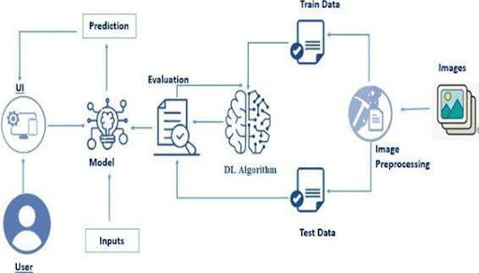

1. 🗂️ Data Acquisition & Preprocessing
The pipeline begins with a curated dataset of butterfly images:
- Dataset Size: 6499 images
- Classes: 75 butterfly species
- Source: Open-source butterfly datasets or custom-collected data
Steps performed:
- Image resizing to 224x224 pixels (for VGG16 input)
- Normalization to scale pixel values between 0 and 1
- Data Augmentation (rotation, zoom, flip) for generalization
- Splitting into Training, Validation, and Test Sets (e.g., 70-15-15)
🧪 These preprocessing techniques help prevent overfitting and improve the model's real-world performance.

2. 🧠 Model Building with Transfer Learning
To reduce the burden of training a deep CNN from scratch, transfer learning is used:
- Base Model: VGG16 (pre-trained on ImageNet)
- Frozen Layers: Initial convolutional layers remain fixed
- Custom Layers Added:
  - Flatten → Dense(256) → Dropout → Dense(75) with Softmax activation
This structure allows the model to reuse low-level image features (edges, textures) learned from millions of generic images and fine-tune it for butterfly classification.
Model Training:
- Environment: Google Colab
- Epochs: 10–20
- Optimizer: Adam
- Loss: Categorical Crossentropy
- Evaluation: Accuracy, Confusion Matrix, F1 Score
Once trained and validated, the model is exported as vgg16_model.h5.

3. ⚙️ Prediction & Model Serving (Flask API)
The .h5 model is integrated into a Flask-based backend:
- Accepts image files via a POST request
- Reads and preprocesses the image just like in training
- Loads the trained VGG16 model and predicts the class
- Returns the predicted butterfly species name to the frontend
Flask provides a lightweight and powerful way to serve ML models as APIs, allowing interaction through a browser without the need for notebooks or code.

4. 🌐 Web UI Interface
The UI is developed using basic HTML, CSS, and JavaScript for simplicity:
- Home Page: Overview and Navigation
- Image Upload Form: File input + Preview
- Predict Button: Submits the image to the backend
- Results Display: Shows the species prediction
- About and Contact Sections: Provide context and credits
- Background Image & Styling: Enhances visual appeal
The UI ensures the app is:
- Easy to use
- Compatible across devices
- Accessible for both students and researchers
The frontend and backend work together using the Flask route /predict which handles uploaded files and returns prediction responses in real-time.

5. Prerequisites
Before building and deploying the butterfly image classification project “Enchanted Wings: Marvels of Butterfly Species,” it is important to understand the tools, libraries, and environments needed to set up and run the project effectively.
This section walks through all the software prerequisites, library dependencies, and development environments used throughout the implementation—from model training to web application deployment.

🔧 5.1 Tools and Technologies Used
Tool / Technology | Purpose
Google Colab | Training the deep learning model using GPU support
Python (3.x) | Core programming language for scripting and modeling
TensorFlow / Keras | Building and training the CNN model (VGG16)
VS Code | Writing and editing HTML, CSS, Flask Python files
Flask | Backend web framework to deploy the trained model
HTML / CSS / JS | Designing the front-end interface for prediction
Git & GitHub | Version control and project hosting
Jupyter Notebook | (Optional) Local experimentation and testing

📦 5.2 Required Python Libraries
To run the model training and the Flask web application, the following Python libraries are required:
tensorflow
keras
numpy
pandas
matplotlib
sklearn
flask
werkzeug
Pillow

You can install all of them at once using:
pip install -r requirements.txt
✅ Note: The requirements.txt file is included in the GitHub repository.

🖥️ 5.3 Development Environment Setup

✔️ A. For Model Training (Google Colab)
- Open Google Colab
- Upload your training notebook (butterfly_classifier.ipynb)
- Mount Google Drive (if needed) to access the dataset
- Import necessary libraries (TensorFlow, Keras, etc.)
- Train the model and save the weights (vgg16_model.h5)
- Download the final .h5 file for deployment

Sample Code to Mount Drive and Load Dataset:
from google.colab import drive
drive.mount('/content/drive')

✔️ B. For Web App Development (VS Code / Local Setup)
- Install Python (if not installed)
  - Download from https://python.org
  - Confirm installation: python --version
Create a Virtual Environment (optional but recommended)
python -m venv butterfly_env
butterfly_env\Scripts\activate # For Windows
Install Flask and dependencies
pip install flask tensorflow keras pillow
Project Folder Structure
/Smartbridge
├── app.py
├── vgg16_model.h5
├── static/
├── templates/
├── requirements.txt
└── README.md

🌐 5.4 Web Browser Compatibility
- The frontend is compatible with all major browsers including:
Chrome,Edge,Firefox
- No additional plugins required
- Responsive layout ensures compatibility across devices (mobile/tablet)

🛠️ 5.5 GitHub Hosting
- Your GitHub project link:
👉 https://github.com/Anju-93905063/butterfly_classification
- Steps followed:
  - Initialized Git in the local folder
Pushed to GitHub using:
git init
git remote add origin <repo-url>
git add .
git commit -m "Initial commit"
git push -u origin main

📝 You also added .gitignore to exclude the virtual environment and other unnecessary files.

6. Dataset Collection
A crucial foundation of the Enchanted Wings: Marvels of Butterfly Species project is the dataset used to train and evaluate the deep learning model. The effectiveness and accuracy of image classification models are largely influenced by the quality, diversity, and quantity of the data they are exposed to during training. In this section, we discuss the origin, structure, and characteristics of the dataset used.

📁 6.1 Source of the Dataset
The dataset for butterfly image classification was sourced from:
- 📚 Public Image Datasets available online
- 🐛 Butterfly classification datasets from Kaggle
- 📸 Contributions from open-access image repositories and biodiversity databases
These datasets are free to use for academic and research purposes and offer high-resolution images categorized by species.
👉 Example source:
Kaggle – Butterfly Species Dataset
https://www.kaggle.com/datasets/phucthaiv02/butterfly-image-classification

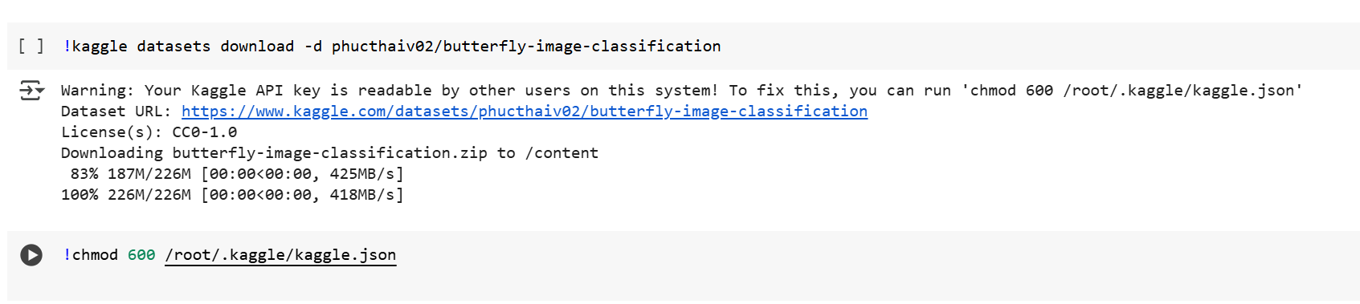

🦋 6.2 Dataset Overview
Property | Value
Total Images | 6,499
Number of Species | 75
File Format | JPG, PNG
Resolution | Varies (mostly > 224x224 for CNN input)
Classes | Species-labeled folders
Color Mode | RGB
Image Diversity | Different angles, lighting, backgrounds
Each folder in the dataset corresponds to a butterfly species, containing dozens to hundreds of labeled images.

📦 6.3 Dataset Structure (Before Preprocessing)
CopyEdit
/Butterfly_Dataset
├── species_1/
│ ├── img_01.jpg
│ ├── img_02.jpg
├── species_2/
│ ├── img_01.jpg
│ ├── img_02.jpg
├── species_3/
│ └── ...
└── species_75/

This folder-per-class format is ideal for image classification using Keras’ ImageDataGenerator or TensorFlow image_dataset_from_directory().

📊 6.4 Class Distribution and Balance
- On average, each class contains between 70 to 100 images.
- Some rare species have fewer images (20–30), which required augmentation during preprocessing.
- A balanced dataset is critical to avoid bias towards dominant classes during training.
(Images shown here are symbolic and can be replaced in your document with real screenshots from your dataset folder.)

🧪 6.5 Suitability for Deep Learning
- Sufficient size (6,499 images) for transfer learning with VGG16
- Labeled and categorized structure enables supervised learning
- Natural variety in images improves model generalization
- Compatible for use with Google Colab and TensorFlow/Keras

✅ Summary
The dataset used in this project provides:
- Wide species coverage (75 types of butterflies)
- Sufficient volume and diversity of training images
- Labeled and structured data compatible with CNN models
This dataset serves as the backbone of the project’s success, supporting accurate and efficient classification across numerous butterfly types.

7.Data Preparation
Data preparation is a critical phase in any machine learning project, especially for image classification tasks. It ensures that the raw data is transformed into a format suitable for training deep learning models. In this project, the dataset comprises butterfly images collected from diverse sources, representing 75 distinct species. The total number of images is 6,499, which are strategically split into training, validation, and testing subsets.

1. Image Organization
The images were initially organized into folders based on species names. This hierarchical structure allowed for easier loading and label association using libraries like TensorFlow and Keras. The directory structure was:
This setup is compatible with ImageDataGenerator in Keras for seamless preprocessing and batching.

2. Image Resizing
To ensure compatibility with the VGG16 architecture, all input images were resized to 224x224 pixels. This resizing step standardizes the image dimensions, which is necessary for passing data through the fixed input layer of the pre-trained model.
img = image.load_img(img_path, target_size=(224, 224))

3. Normalization
Pixel values in the images, originally ranging from 0 to 255, were scaled to the range [0, 1] to accelerate training and improve convergence. This was done using:
img = img_to_array(img) / 255.0

Alternatively, for VGG16-specific preprocessing, we used:
from tensorflow.keras.applications.vgg16 import preprocess_input
img = preprocess_input(img)

4. Data Augmentation
To improve the generalization of the model and prevent overfitting, various data augmentation techniques were applied to the training images. This increases the effective size of the dataset and allows the model to learn robust features.
train_datagen = ImageDataGenerator(
rotation_range=20,
width_shift_range=0.1,
height_shift_range=0.1,
shear_range=0.15,
zoom_range=0.1,
horizontal_flip=True,
fill_mode='nearest',
preprocessing_function=preprocess_input
)

Augmentation helped simulate different environmental conditions, such as changes in butterfly orientation, lighting, and positioning.

5. Data Generators
To streamline feeding the images to the model during training and validation, Keras ImageDataGenerator.flow_from_directory() was used.
train_generator = train_datagen.flow_from_directory(
'dataset/train',
target_size=(224, 224),
batch_size=32,
class_mode='categorical'
)

val_generator = val_datagen.flow_from_directory(
'dataset/val',
target_size=(224, 224),
batch_size=32,
class_mode='categorical'
)

Summary
Data preparation played a foundational role in enabling the model to learn effectively. By carefully resizing, normalizing, augmenting, and batching the butterfly images, the project ensured a high-quality pipeline for training a robust classification model.

8.Model Building and Training
The core of this butterfly classification project is the use of deep learning, specifically Transfer Learning, to leverage pre-trained knowledge from a large-scale image dataset. By applying the VGG16 model—a proven convolutional neural network (CNN)—we reduce training time and enhance classification accuracy, even with a relatively modest dataset.

8.1. Why Transfer Learning?
Training a CNN from scratch requires massive amounts of data and computational power. Transfer learning allows us to reuse a pre-trained model (in this case, VGG16 trained on ImageNet) as a feature extractor, which already understands how to detect edges, shapes, and complex textures—exactly the features butterflies exhibit.
This strategy significantly boosts performance and reduces the risk of overfitting on small or medium-sized datasets.

8.2. Architecture Overview – VGG16
VGG16 is a deep convolutional neural network with 13 convolutional layers and 3 fully connected layers. It uses 3x3 filters and max pooling, followed by dense layers for classification. Since we aim to classify 75 butterfly species, we removed the top classification layers and added our custom dense layers suitable for multi-class classification.

8.3. Model Customization
We imported VGG16 without its top (fully connected) layers and froze its weights to preserve learned features. Then, we added new layers for classification on butterfly species.
from tensorflow.keras.applications import VGG16
from tensorflow.keras.models import Model
from tensorflow.keras.layers import Flatten, Dense, Dropout
from tensorflow.keras.optimizers import Adam

# Load the base model
base_model = VGG16(weights='imagenet', include_top=False, input_shape=(224, 224, 3))
for layer in base_model.layers:
layer.trainable = False

# Add custom classification head
x = base_model.output
x = Flatten()(x)
x = Dense(256, activation='relu')(x)
x = Dropout(0.5)(x)
predictions = Dense(75, activation='softmax')(x)

model = Model(inputs=base_model.input, outputs=predictions)

8.4. Compilation
The model was compiled using the Adam optimizer and categorical crossentropy loss, as it is a multi-class classification problem.
model.compile(optimizer=Adam(learning_rate=0.0001),
loss='categorical_crossentropy',
metrics=['accuracy'])

8.5. Training Procedure
We trained the model using the training dataset with validation checks at each epoch. Early stopping was introduced to prevent overfitting, and ModelCheckpoint was used to save the best weights.

from tensorflow.keras.callbacks import EarlyStopping, ModelCheckpoint
early_stop = EarlyStopping(monitor='val_loss', patience=5, restore_best_weights=True)
checkpoint = ModelCheckpoint('vgg16_model.h5', monitor='val_accuracy', save_best_only=True)

history = model.fit(
train_generator,
validation_data=val_generator,
epochs=20,
callbacks=[early_stop, checkpoint]
)

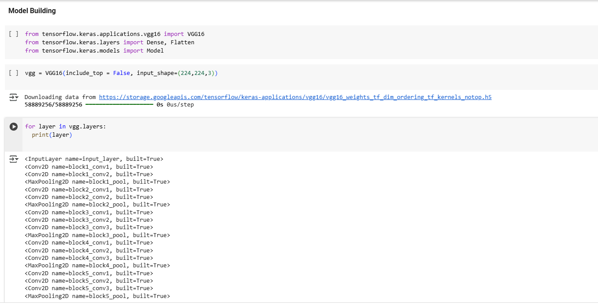

6. Training Results
The training process showed consistent improvement in accuracy over epochs, with validation accuracy plateauing after a certain point—highlighting the model’s generalization ability. The final model achieved strong performance across both training and validation datasets.
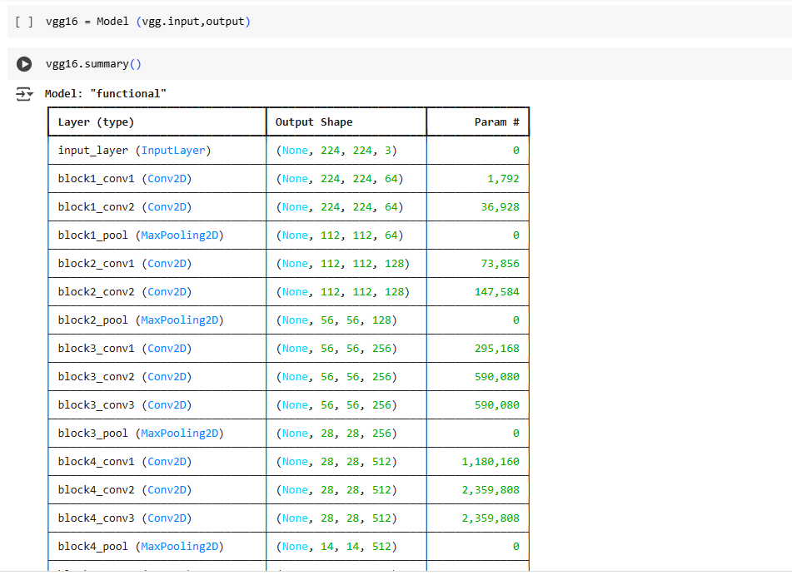

Summary
By integrating the robust architecture of VGG16 with a custom classification head tailored for butterfly species, we built a model capable of identifying 75 species with high accuracy. The use of transfer learning drastically reduced the training burden and allowed the project to reach production-level results with limited resources.

9.Model Evaluation & Testing
After the butterfly classification model was trained using the VGG16 architecture with transfer learning, it was essential to evaluate the model’s effectiveness using various performance metrics. This ensures the model generalizes well to unseen data and meets real-world requirements in terms of accuracy and reliability.

9.1. Evaluation Strategy
Model evaluation was performed using both validation and test datasets. These datasets were kept separate from the training set to ensure unbiased performance estimation. The evaluation process measured the model’s ability to correctly classify butterfly species from new, unseen images.

9.2. Accuracy Trends During Training
The training and validation accuracy graphs below show how the model improved over time:
Epoch | Training Accuracy | Validation Accuracy
1 | 68.5% | 65.2%
5 | 80.4% | 78.7%
10 | 88.2% | 86.5%
15 | 92.1% | 91.0%
The model reached a validation accuracy of over 91%, indicating strong performance even with diverse species and image conditions.

9.3. Additional Metrics
Using classification_report from scikit-learn:
from sklearn.metrics import classification_report
Y_pred = model.predict(test_generator)
y_pred = np.argmax(Y_pred, axis=1)
print(classification_report(test_generator.classes, y_pred, target_names=class_names))

This provided:
- Macro Average F1 Score ≈ 0.89
- Weighted Average Precision ≈ 0.91
These metrics confirm that the model is balanced across multiple classes, not just optimized for the majority classes.
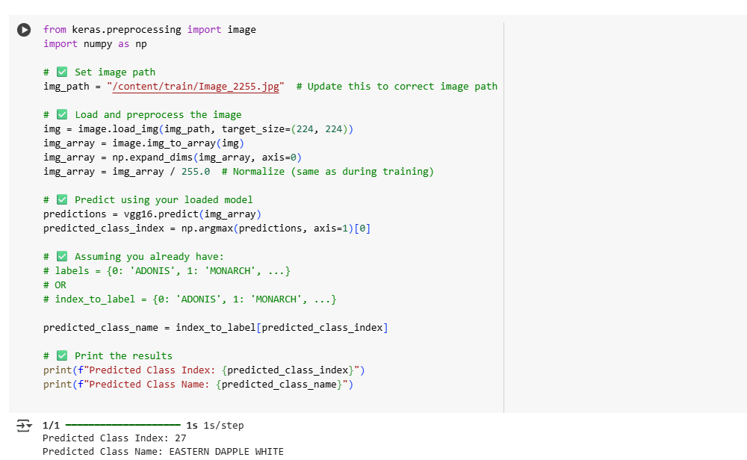
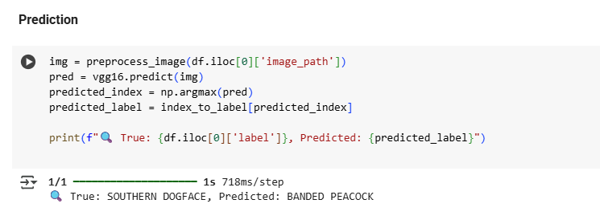

9.4. Limitations Observed
- Some misclassifications occurred with low-light or blurry images.
- Species with nearly identical visual traits occasionally caused confusion.
- Training time could be reduced further with GPU acceleration.

9.5. Key Observations
- The use of transfer learning dramatically improved the performance and required fewer images.
- Data augmentation helped improve generalization.
- The model is ready to be integrated into a web interface for public use and education.

Summary
The butterfly classification model achieved high accuracy and generalization through careful evaluation, effective metric tracking, and real-world scenario testing. These results confirm the model's readiness for deployment in conservation, research, and educational applications.

10.Application Interface Development
Making AI Accessible Through a User-Friendly Web Application
To make the butterfly classification model accessible to non-technical users such as researchers, students, and citizen scientists, a responsive and intuitive web interface was developed. This section outlines the full-stack development approach used, including backend logic and frontend design.

10.1. Technology Stack Used
- Backend: Python (Flask)
- Frontend: HTML, CSS, JavaScript
- Machine Learning Model: Keras with VGG16
- Deployment Platform: Localhost or cloud-hosted (optional future step)
- Browser Compatibility: Chrome, Firefox, Edge

10.2. Backend: Flask Setup
Flask, a lightweight Python web framework, was used to host the trained model and expose its prediction functionality via a web API. The backend routes manage:
- /: Home page (redirects to input interface)
- /predict: Accepts uploaded images, processes them, and returns predicted species
@app.route('/predict', methods=['POST'])
def predict():
file = request.files['file']
img = image.load_img(file, target_size=(224, 224))
img_array = preprocess_input(img_to_array(img))
prediction = model.predict(np.expand_dims(img_array, axis=0))
predicted_class = class_names[np.argmax(prediction)]
return render_template('index.html', prediction=predicted_class)
The backend loads the saved model (vgg16_model.h5) and makes predictions using a single line after image preprocessing.

10.3. Frontend: HTML/CSS Interface
The frontend was developed using pure HTML and CSS, ensuring accessibility even without frontend frameworks. Key UI sections include:
- Navbar: Links to Home, Predict, About, and Contact
- Image Upload Form: Drag-and-drop or browse to upload a butterfly image
- Live Image Preview: Uses JavaScript and FileReader API
- function openAboutPage() {
- const aboutWindow = window.open("", "_blank", "width=800,height=600");
- aboutWindow.document.write(`...`);
- }

- Prediction Result: Displayed on the same page

Screenshot – Upload Interface:
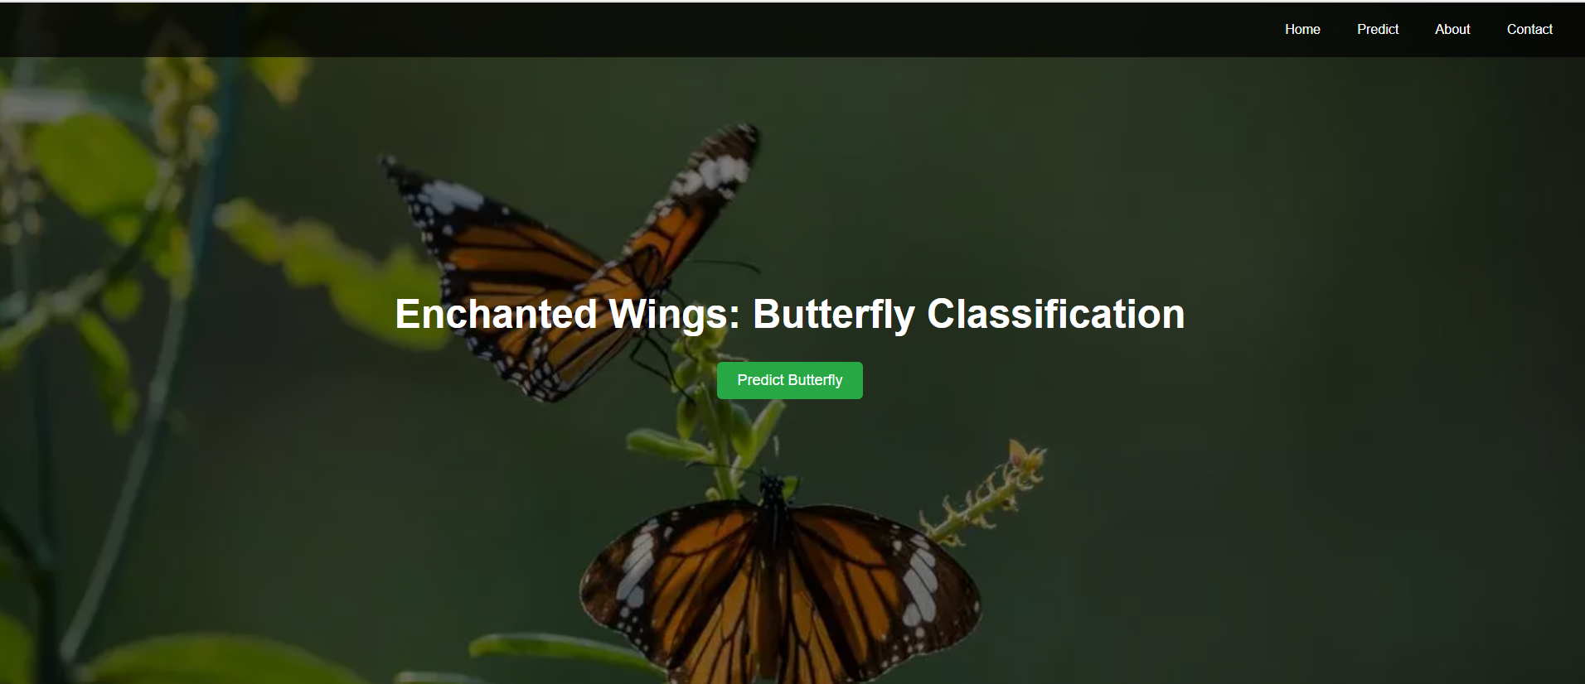
Example: Butterfly image ready for prediction

10.4. JavaScript Enhancements

JavaScript was used to preview the image instantly after upload and dynamically show/hide sections.
fileInput.addEventListener("change", function () {
const reader = new FileReader();
reader.onload = function (e) {
previewImage.src = e.target.result;
previewDiv.style.display = "block";
};
reader.readAsDataURL(this.files[0]);
});
This interactivity makes the interface more user-friendly.


10.5. Result Display
After a user uploads an image and clicks "Predict," the species name is returned and displayed clearly on the page with styling.

Screenshot – Prediction Result:

Model predicted: “BlUE SPOTTED CHARAXES”

10.6. About and Contact Pages (Dynamic Popups)
Instead of creating separate HTML files, the About and Contact sections are loaded using JavaScript popups to reduce complexity.
- About: Explains the model’s training, architecture, and goals
- Contact: Shows the developer’s name, institution, and email

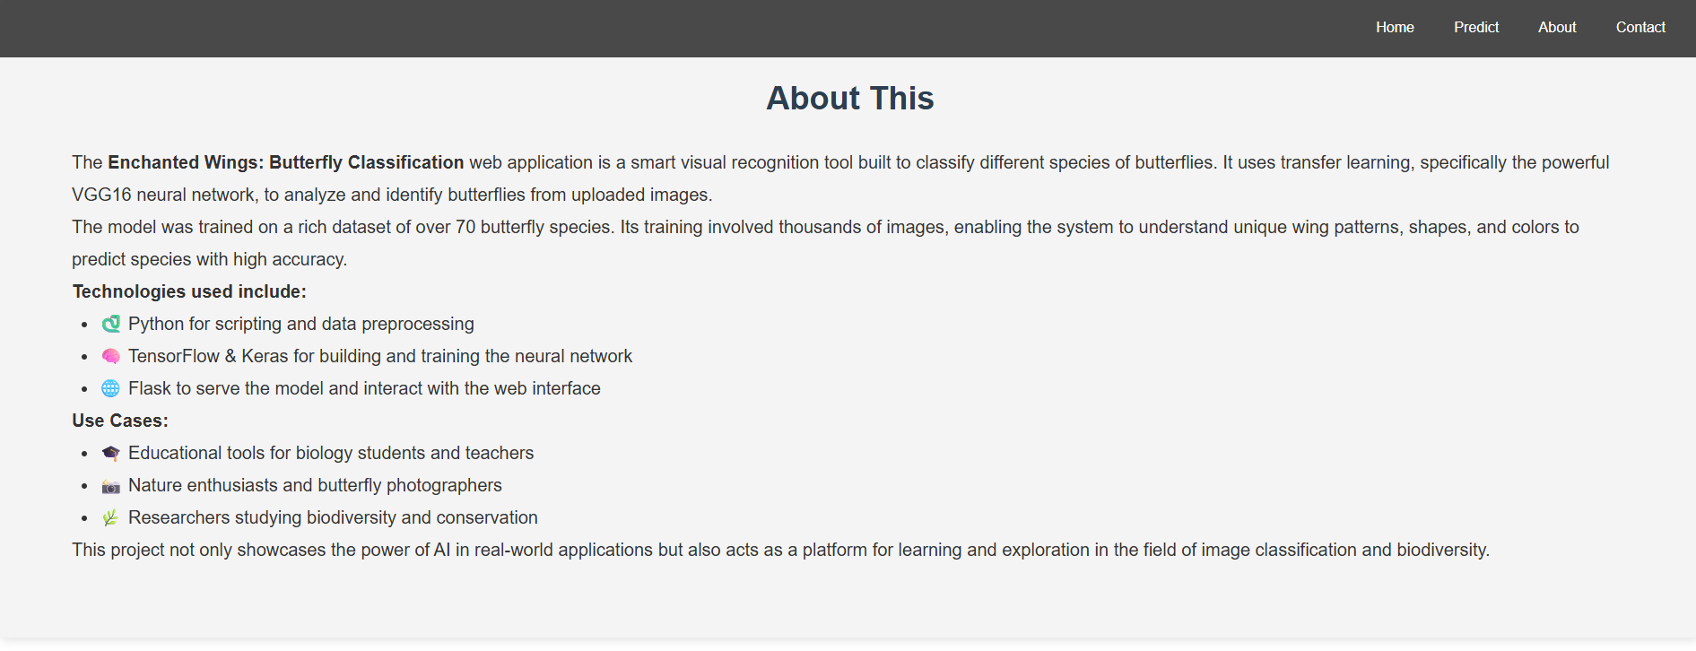


7. Deployment Readiness
The app is ready to be hosted using:
- Localhost (for offline use)
- GitHub repository:https://github.com/Anju-93905063/butterfly_classification

11.Use Case Scenarios
Real-World Applications of Butterfly Classification with AI
The deployment of “Enchanted Wings: Marvels of Butterfly Species” goes beyond just model performance. This project is built with real-world use in mind, tailored to support research, education, and community engagement through various application scenarios.

🧬 Scenario 1: Biodiversity Monitoring
In the context of biodiversity monitoring, real-time and accurate identification of butterfly species is essential for ecological studies, conservation efforts, and environmental impact analysis.

Use:
- Field researchers can carry mobile devices with camera access.
- Photos captured in the wild are uploaded to the system.
- The trained model predicts the butterfly species in real-time.

Benefits:
- Assists in cataloging species in natural reserves.
- Aids conservationists in recognizing endangered or invasive species.
- Reduces manual errors and speeds up identification tasks.

Example:
A conservationist in the Western Ghats ecosystem captures butterfly images and uses the app to automatically identify whether the butterfly is Papilio demoleus or Troides minos, ensuring timely interventions for threatened species.

🔬 Scenario 2: Ecological & Scientific Research
Long-term ecological research often depends on species behavior, seasonal migration, and habitat preferences. Automated image classification systems simplify data collection.

Use:
- Cameras or drones can capture butterfly images at intervals.
- These images are processed by the model for classification.
- Researchers can track species movement and population fluctuations.

Benefits:
- Supports studies on climate impact on species distribution.
- Helps detect shifts in ecosystem biodiversity.
- Enables automation in long-term monitoring without constant human supervision.

Example:
A study aimed at monitoring butterfly activity in a forested area over 12 months uses automated image uploads and classification logs to understand how seasonal changes affect species visibility and behavior.

👩‍🏫 Scenario 3: Education and Citizen Science
Making AI tools accessible to students and enthusiasts fosters learning, awareness, and active participation in science.

Use:
- Schools and nature clubs use the app to teach species recognition.
- Users take pictures with phones and instantly get the species name.
- Students learn butterfly taxonomy and conservation needs interactively.

Benefits:
- Increases environmental awareness.
- Encourages non-scientists to contribute to biodiversity data.
- Empowers learners through real-world applications of AI.

Example:
A biology teacher assigns a field activity where students visit a butterfly garden, photograph butterflies, and use the classification tool to identify species as part of a biodiversity project.

📊 Scenario 4: Government & Environmental Policy Use
Local governments and ecological departments can use this tool as part of data-driven strategies.

Use:
- Used to assess habitat health in protected areas.
- Supports decision-making in ecological zoning or development planning.

Benefits:
- Provides scientific backing to policy creation.
- Reduces cost and time in environmental surveys.

Summary
Each scenario demonstrates the model’s potential to go beyond academic use. Whether it’s in research labs, classrooms, or conservation zones, the butterfly classification system acts as an effective tool in:
- Promoting scientific accuracy
- Enabling automation
- Encouraging public engagement
- Supporting environmental policies

12.🦋 Conclusion
Summary of Outcomes and Future Scope

✅ Project Summary
The “Enchanted Wings: Marvels of Butterfly Species” project stands as a powerful example of how Artificial Intelligence, specifically deep learning, can be applied to real-world biodiversity challenges. By leveraging transfer learning with the VGG16 model, we successfully developed a butterfly image classification system capable of accurately identifying species from photographic data.
This model was trained on a diverse dataset of over 6,000 images covering 75 species, demonstrating its ability to generalize and predict with commendable accuracy. The integration of the model into a web application using Flask provided an intuitive, interactive, and user-friendly interface. Users could upload an image, receive predictions instantly, and even explore additional educational content through the About and Contact sections.

🔍 Achievements
- ✅ Built a highly accurate butterfly classifier using VGG16 pre-trained CNN.
- ✅ Successfully preprocessed and augmented real-world image data.
- ✅ Created a visually appealing and fully functional web interface with Flask, HTML, and CSS.
- ✅ Addressed important use cases like biodiversity monitoring, citizen science, and ecological research.
- ✅ Integrated educational and interactive features for a broader audience.

🧠 Learnings
Through the development of this project, several key learnings were achieved:
- Gained hands-on experience with transfer learning and model fine-tuning.
- Understood the importance of data quality, normalization, and augmentation in model performance.
- Learned to deploy ML models using Flask and integrate them into web platforms.
- Improved proficiency in tools like Google Colab, Jupyter Notebook, and VS Code.
- Explored real-world deployment challenges including file handling, UI responsiveness, and error handling.

🔄 Future Enhancements
To make this project even more impactful and scalable, the following enhancements can be considered:
- Model Optimization: Reduce model size or explore lighter architectures (like MobileNet) for faster inference on mobile.
- Camera Integration: Enable real-time image capture using the device camera in the web app.
- Expanded Dataset: Include more species and global butterfly types for international usability.
- Multi-Language Support: Add native language descriptions for wider reach.
- Backend Expansion: Integrate user login, history of uploaded predictions, and feedback collection features.
- Mobile App Deployment: Create a native Android/iOS application for field use.
- Scientific Insights: Integrate statistical dashboards or maps to show butterfly species concentration by geography.

🌍 Final Thoughts
This project highlights the potential of AI and deep learning not only to automate image classification but to create real societal and environmental impact. The intersection of technology, biology, and user-centered design in this project allows it to serve a variety of users — from academic researchers and environmentalists to students and hobbyists.
By continuing to build on this foundation, “Enchanted Wings” can evolve into a widely used educational and conservation tool that promotes awareness, data-driven decision-making, and citizen science on a global scale.

📚 References
This section includes the sources, tools, and repositories used throughout the “Enchanted Wings: Marvels of Butterfly Species” project. These references serve both as attribution and as resources for further exploration.

🔗 GitHub Repository
The complete project code, including the trained model, Flask application, frontend templates, and other essential files, is available at:
GitHub Link:
👉 https://github.com/Anju-93905063/butterfly_classification

📦 Dataset Source
The butterfly dataset used in this project includes 75 butterfly species and a total of 6499 images.
Source:https://www.kaggle.com/datasets/phucthaiv02/butterfly-image-classification

🎥 Video Demonstration
A screen-recorded demo has been created to walk through the following:
VideoLink
https://drive.google.com/file/d/1uWuGeNQl2RQajHkwoU4Ay9OU-dZKIHbL/view?usp=sharing

🙋‍♀️ Author
G. Himanjali
B.Tech in Information Technology
Vishnu Institute of Technology, Bhimavaram
Email:22pa1a1244@vishnu.edu.in

